ROTARY CLUB OF LIVERMORE
A Member Club of Rotary International

WHAT IS ROTARY?
Rotary is a service club. Its business is mankind; its product is service therefore creating an opportunity to do something for somebody else and at the same time enjoy a sense of fulfillment that this brings.
Members of the club are:
• Business Leaders
• Professional Leaders
• Community Leaders
Members meet weekly to plan and implement community service activities and network with other professionals.
CORPORATE MEMBERSHIP
A Corporate Membership is offered to executive leaders of major businesses, allowing them to join the club with a flexible attendance requirement.
Why should your organization be a part of Rotary?
Membership - Be a member of a select group of individuals from a wide cross-section of business, public and cultural institutions.
Networks - Develop relationships with leaders from a wide array of Livermore businesses and life.
Corporate Image - Rotary is a highly respected philanthropic icon in both local and international communities.
Leadership - Provides leaders-in-training with significant avenues for application of their experience.
World Citizenship - Promote world peace through contacts shared among Rotarians in more than 34,000 clubs worldwide.
Access - Access to a pre-screened audience that conducts its business and personal relationships in an ethical manner.

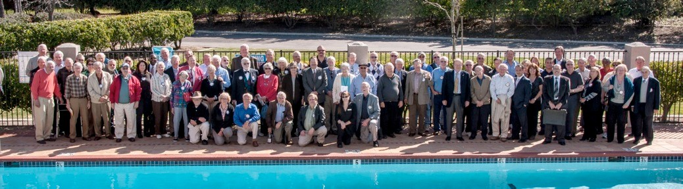

The 135 members of the Rotary Club of Livermore

Bottom Line

A business leader’s time is precious. As are the relationships fostered by the Rotary Club of Livermore. The flexibility of Corporate Memberships now allows the leaders of prominent businesses to maximize both their time and their relationships for the betterment of themselves, their companies and the greater Livermore community.

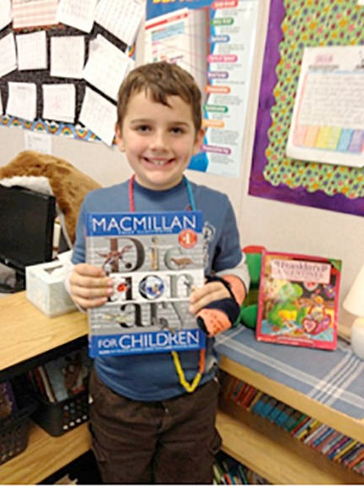Club Projects - Local

Every 3rd grade child in Livermore is given an illustrated dictionary every year.

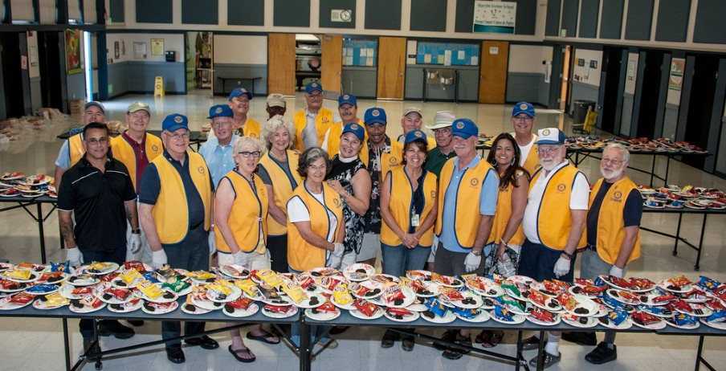
Every year the club is the host for 1,000 students and parents at a return to school BBQ
International Projects
• Install Pediatric Emergency Clinic in Kosovo
• Provide school for the mentally disabled in Brazil with a modern teaching kitchen
• Install composting toilets in a community in
Nicaragua

For more information about the Rotary Club of Livermore, please go to the club’s website: www.livermore-rotary.org or write to the club Secretary: p secretary@livermore-rotary.org

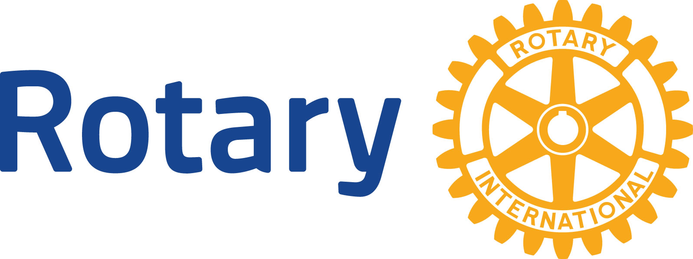

Rotary Club of Livermore
Great people doing great things, together Corporate Membership

Club #485
District 5170
Rotary International

P.O. Box 694
Livermore, CA 94551-0694
www.livermore-rotary.org

